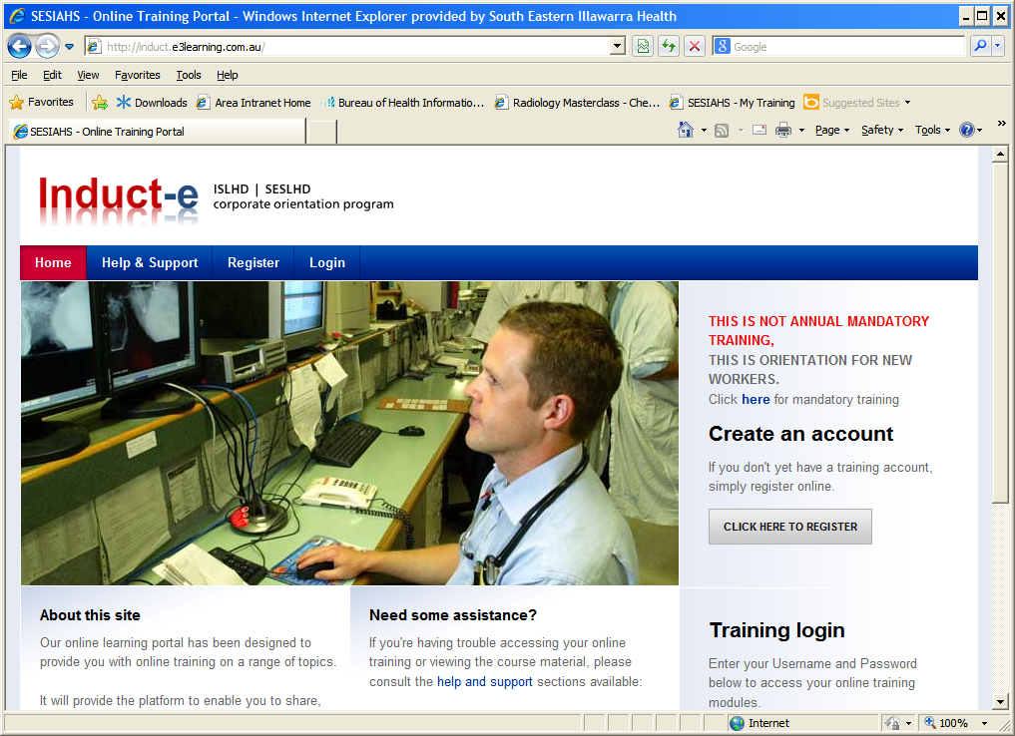
Log onto the Internet Explorer /Firefox
Type this link into the browser (do not google)
http://induct.e3learning.com.au
Create an account by
clicking on
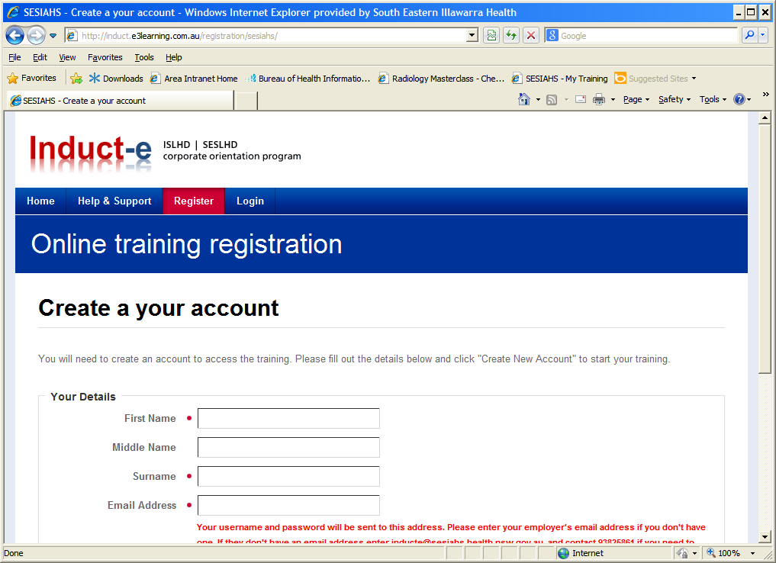
Complete all fields marked with an asterisk
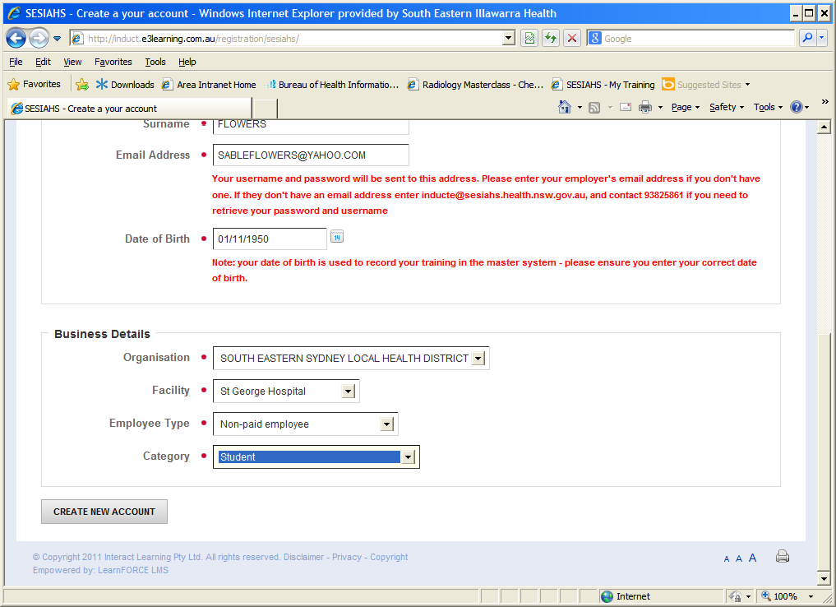
Make sure you select the following
South Eastern Sydney Local Health District
St George Hospital
Student
Then click on Create New Account

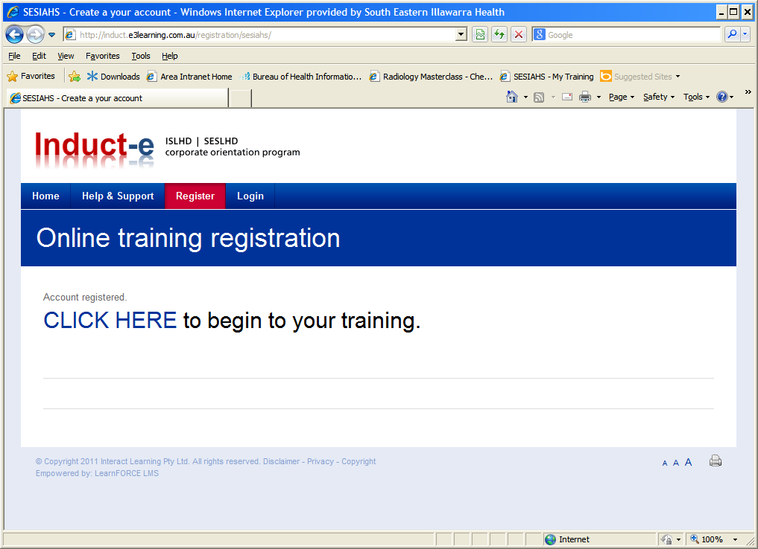
You are now ready to begin your training
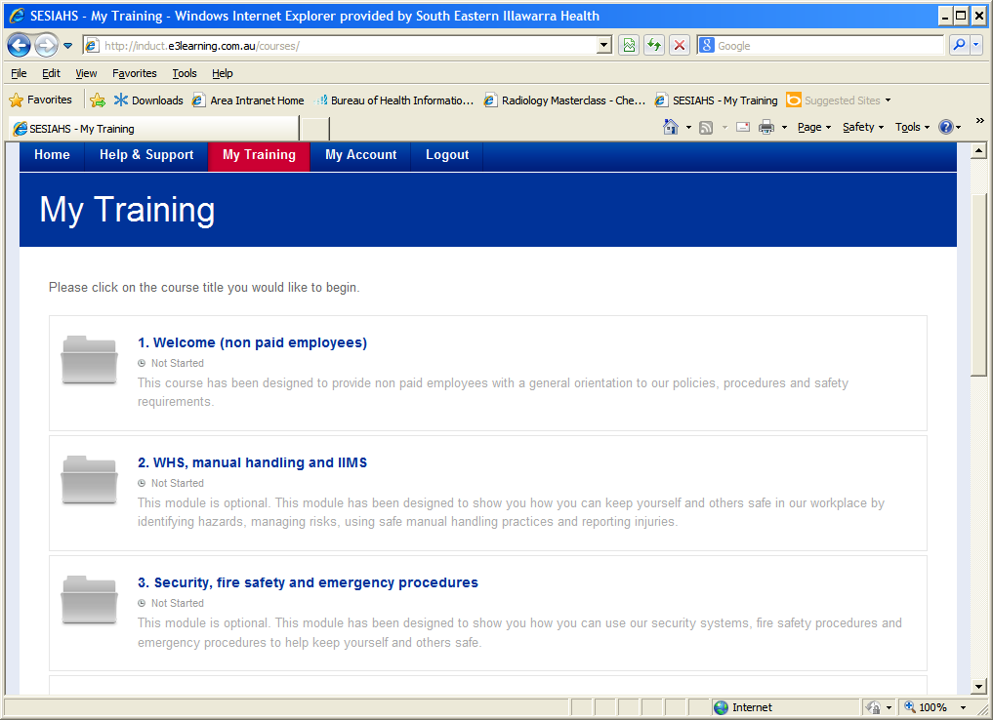
There are 9 topics.
You only need to complete the first topic “Welcome” the other topics are optional – takes 15 mins to complete

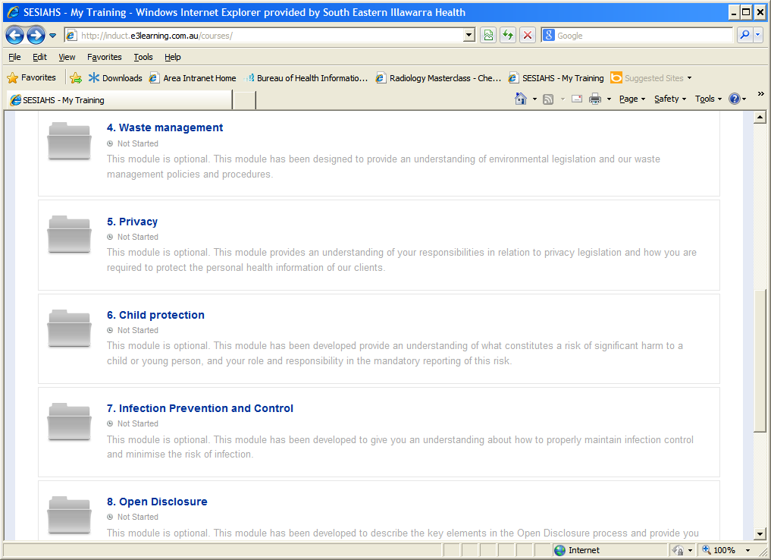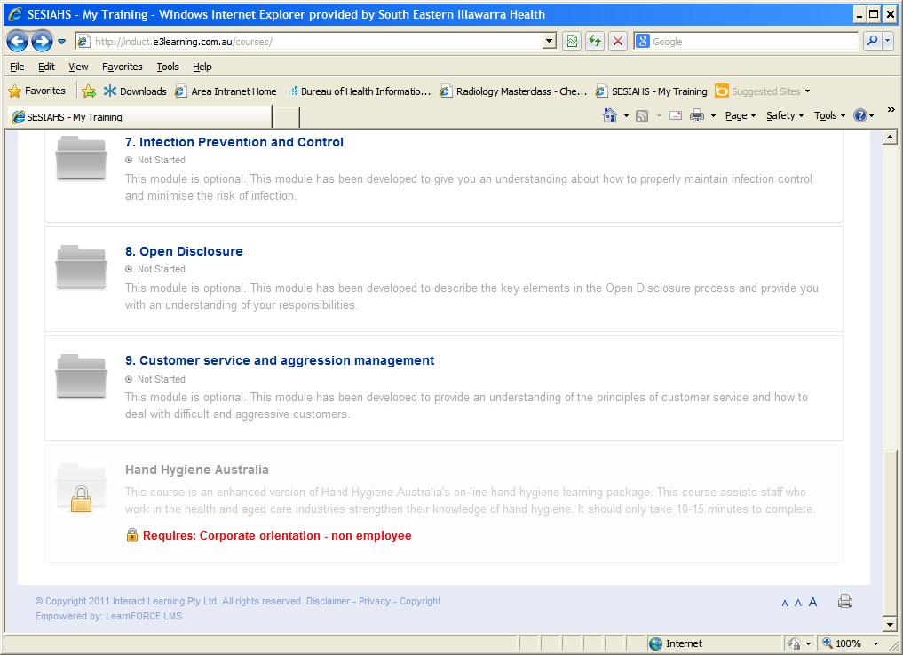
Once you have completed all nine topics you will be issued with a Certificate of Completion.
Please forward this certificate to me Heather.shepherd@sesiahs.health.nsw.gov.au
Thanks

